**Summary**

First is the calculation of wasted time. For our model to work correctly we developed a simple metric that would measure the amount of time wasted when merging from one lane to an adjacent lane where there was traffic such that the vehicle we are observing could not make a fluid transition. Waste time is calculated using the "worst case scenario" in which when two vehicles meet at a merge point, that are always adjacent so that the ideal driver in the merge lane loses the most time possible.

In order to apply our metric of time lost in a worst-case merging scenario, it is necessary to develop a sense of the likelihood of such an event (merge interaction) happening at various points in our traffic system. In order to develop this we looked at the way in which starting lanes affected the number of lanes a car would minimally need to cross. From this perspective, plaza layouts that have multiple merge lanes adjacent to each other increase the probabilities of the individual cars having to waste time merging and thus wasting more time all under the assumption that we have a sufficiently random distribution of traffic among lanes.

In order to evaluate the efficiency of our system as a whole, we summed together all of our probabilities across our lanes and divided that by the number of possible interactions in the system. This gave us an expected value of wasted time spent merging for every car. Given this we calculated Throughput for each of the three plaza layouts considered.

**I. Calculating Waste Time**

For our model to work correctly we needed a metric that would measure the amount of time wasted when merging from one lane to an adjacent lane where there was traffic such that the vehicle we are observing could not make a fluid transition into the lane adjacent to them. We call this metric “waste time” and denote it with T.

For calculating T we decided it was best to compare the most inefficient scenario of merging patterns. We call this our “worst-case scenario,” and we will further use this idea to create the structure of our model. Before we could start calculating our waste time we had to make some assumptions based on how cars accelerate, what distance was needed between car A that would be merging and car B who would be merged into, and what the length of a typical car would be. We first had to figure out what the average acceleration of a car was. To do this we looked at “Top 20 Most Popular Used Cars in the U.S.”[1] and then found corresponding 0 to 60 mph times for each model over the last 20 years. After averaging all car data from our table (located in the appendix) we found that the average time from 0 to 60 mph was roughly 7.262 seconds. We could then calculate the average acceleration fairly easily from some simple maths.

Average acceleration = Aavg =

then to find acceleration in ft/s2 we just have some simple conversions:

Aavg =

We then found the average car length to be roughly 4.5 meters[2] which is equivalent to 14.7638 feet. Now we had to make another assumption on how far our distance would be, and we chose 500 feet. This is just a figure to use so we can represent how we find a generalized model of waste time.

The next assumption we made is that at half the distance to the end of our merging lane car A will begin to decelerate at the same rate that it was accelerating.

Now we can begin to look at our worst case scenario as part of our model.

Figure 1:

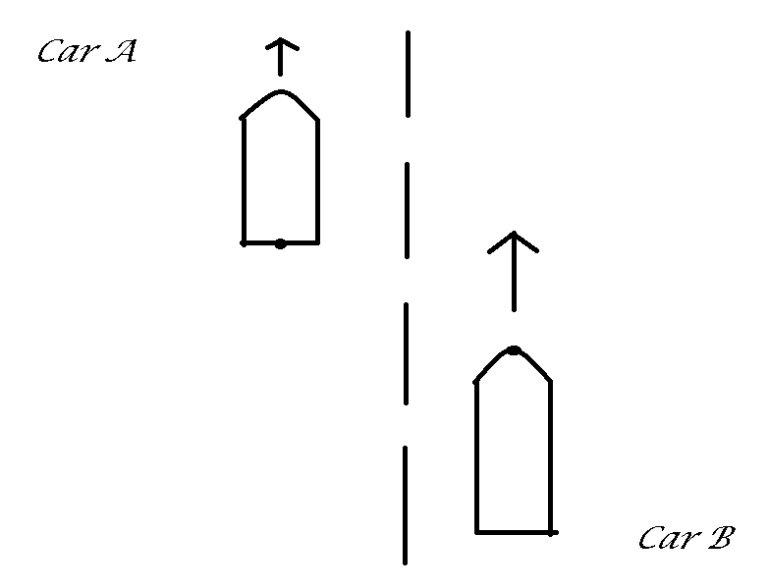

The next assumption we made was that to safely merge; a human driving Car A would need at least a car length vertically between itself and Car B. In our worst case scenario Car A is going to be at the mathematical limit of 1 car length from below. This gives us the most wasted time as it assures us we will have to decelerate for the maximum amount of time before we can merge behind Car B. This gives us a value of 4 car lengths that Car A must lose to Car B to be in our merge area at 1 car length behind Car B. Another assumption we make is that all cars are accelerating at the same rate, and thus we can now calculate how long it will take car A to get into the correct merge position.

Now that Car A is 1 car length ahead we will need to calculate the difference in velocities between Car A and Car B which is what we will need to find out how long Car A will need to decelerate for. We can do this with some more simple physics:

C = Car length = $(\frac{1}{2})(A_{avg}){(t)}^{2}$

We calculate this through the idea that the front most point of Car B is equal to 0 car lengths while the back most point of Car A is equal to 1 car length, and thus Δt = tA -tB = tA - 0 = tA = t. When we plug in our data we obtain:

$$14.7638=(\frac{1}{2})(\frac{12.1170ft}{1s^{2}}){(t)}^{2}$$

Then we rearrange to find:

$$t=\sqrt{\frac{2(14.7638)ft*s^{2}}{12.1170ft}}=1.5610seconds$$

Where t is how much more time car A has had to accelerate than Car B. With this we can now find the difference in velocities of the 2 cars:

$$ΔV=(A_{avg})(t)=(\frac{12.1180ft}{1s^{2}})(1.5610s)=\frac{18.9162ft}{1s}$$

Now since we assumed that both acceleration and deceleration were going to have the same value but in different directions we can say:

$$TotaldecelerationofCarA=A_{T}=-A_{avg}-B_{avg}=-2(A_{avg})=-2(\frac{12.1170ft}{1s^{2}})=\frac{-24.2340ft}{1s^{2}}$$

Now the only thing left to do is find out how long it will take to cover 4 car lengths of distance using the information we have already obtained, and to do that we will use:

$$Distance=4(C)=-A_{avg}{(T)}^{2}+ΔV(T)$$

With some rearranging we find:

$$T_{D}=0=-A_{avg}{(T)}^{2}+ΔV(T)+4(C)$$

Where TD is time spent decelerating, which is a model-able quadratic function, and by finding 0 we will have the time wasted for Car A to merge into Car B's lane. Using the quadratic equation we have: (units left out for cleanliness)

$$T_{D}=\frac{-ΔV±\sqrt{{(ΔV)}^{2}-4(-A_{avg})(4C)}}{2(-A_{avg})}=\frac{-18.9162±\sqrt{{(18.9162)}^{2}-4(-12.1170)(4(14.7638))}}{2(-12.1170)}$$

$$T_{D}=\frac{-18.9162±\sqrt{{(18.9162)}^{2}-4(-12.1170)(4(14.7638))}}{2(-12.1170)}=\frac{-18.9162±56.7460}{-24.2340}$$

Now by looking at the equation we can see that the only case that makes sense is:

$$T_{D}=\frac{-18.9162-56.7460}{-24.2340}=3.1222seconds$$

Therefore our time wasted decelerating is 3.1222 seconds, however we will also need to account for time accelerating back up to traveling velocity of 60 mph. Thus we can say that because acceleration and deceleration are the same rate we must double our time wasted to get total time wasted. This is because we must assume that if we reach a velocity, and then must decelerate, we must also accelerate back to that velocity before we would be in line with a straight acceleration to our traveling speed.

So now we finally have:

$$T=\frac{-18.9162-56.7460}{-12.111170}=6.2444seconds$$

and our general model for finding wasted time with N car lengths instead of 4 is:

$$T=\frac{-ΔV±\sqrt{{(ΔV)}^{2}-4(-A_{avg})(NC)}}{(-A_{avg})}$$

**II. Probability**

In order to apply our metric of time lost in a worst-case merging scenario, it is necessary to develop a sense of the likelihood of such an event (merge interaction) happening at various points in our traffic system. In order to develop this we looked at the way in which starting lanes affected the number of lanes a car would minimally need to cross.

Some key assumptions were necessary for our probability model. First, we assumed that any car already in a “through lane” – meaning one which requires no merging and feeds directly into the freeway – will not make any merges. We consider that any merge made by cars in the interest of distributing across our through lanes will be made out of convenience and not significantly add to our wasted time. In reality, this distribution of cars will reduce the probability of a merge interaction at later stages and should reduce the overall waste time. Next, we assumed that cars do not merge until their lane ends – as with our through lanes, merges made prior to the end of a lane will be considered to be merges of convenience which do not contribute in a significant way to waste time. Finally, we assume that the likelihood of the adjacent lane being occupied at merge time is proportional to the number of lanes being fed into it as a fraction over the number of lanes involved. We’ll examine some of our selected traffic patterns in detail to clarify this process.

Figure 2:

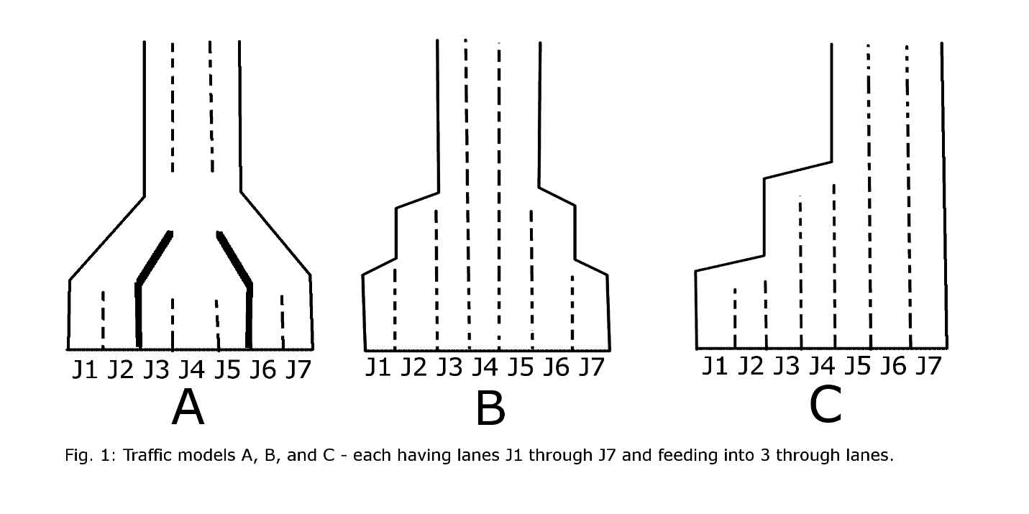

First, let’s look at model A. Here we have three lanes which begin as through lanes – J2, J4 and J6. The other lanes will be the ones merging into these through lanes. In our model, the bold lines represent barriers or other means of keeping the separated lanes from interacting with one another. J1 then is only required to merge once into the through lane J2. We consider the probability of a merge interaction at this point to be 1/2 as one lane of the two involved will be merging into the through lane. Similar interactions will occur between J6 and J7. The interaction between our central lanes is more interesting (any odd numbered amount of booths arranged in an A-like fashion will have one such triplet). Both J3 and J5 are feeding into J4, but cannot do so simultaneously. To arrive at a probability at these junctures, we examined first the probability of an interaction with the adjacent lane (2 lanes merging of 3 or 2/3) and the probability of there being an interaction across both the adjacent and opposite lanes (a sum of our two lane likelihood of 1/2, and our three lane likelihood of 2/3 – a total of 7/6). We then took the average of these two as in any given interaction with cars competing on opposite sides, one will go first – thereby locking itself into the lower probability. This gave us our probability of each lane J3 and J5 having a merge interaction of 11/12.

In model B, we have cars which will need to cross multiple times in order to reach a through lane. We consider this probability to be additive. In example, J1 of model B will first need to merge into J2, a probability of 1/2. Next it will need to merge from J2 to J3, a probability of 2/3 (as both J1 and J2 feed into J3). Our total probability for J1 to have a merge interaction in model B is then 7/6. Our C model’s probability is a combination of this summation across multiple merges, but as we see some lanes merging across two lanes at a time in J1 and J3 we again used the evaluation method we saw in examining the “triplet” which occurred in model A.

Additionally, we examined our models as various numbers of lanes were opened – this allowed us to look at the efficiencies of various numbers of booths under our merge pattern in various traffic densities. We consider any booth used in excess of the number which allows us to service cars at their arrival rate to be unnecessary and examined closing them with the highest probabilities closing first (we adjusted our probabilities to reflect this change of lanes feeding into the system).

In order to evaluate the efficiency of our system as a whole, we summed together all of our probabilities across our lanes and divided that by the number of possible interactions in the system (always one less than our number of lanes as cars do not need to merge into their own lane). This gave us an expected value of wasted time spent merging per car. Full probability information for each of our models is available in table 1 (located in the appendix).

**III. Calculations of our Model**

**Assumptions/Arguments**

**1. Assume sufficiently random distribution of traffic across all lanes approaching booths.**

To construct this model we started with the simplest case. all booths were considered to be human operated booths and that the distribution of cars coming from the free lanes into the egress lanes will be sufficiently random.

**2. Ideal drivers**

We are assuming that drivers on the road will be what we call “Ideal drivers” which is just to say that if a driver is in a merging lane, they will wait for a safe distance to merge in front of or behind a car in a non merging lane. In another case we are assuming that a driver will not merge if there is no merge room, and if the road begins to end they will wait until they have a safe 1 car length merge zone.

**3. Consistent operated booth times**

We are assuming that all booth times are the average booth time, and that they will not vary unless they are differentiating by operating type (Human operated vs. Exact change operated).

**4. Buddies system**

We are assuming that if a car is traveling at maximum density it will always be traveling with other cars in all other lanes on the freeway.

**Cost:**

The needed cost to convert existing toll plazas would require highway barriers in between lanes. This model requires adding one solid barrier along every running lane if that lane is not on the end of the highway. The minimum merge lane length denoted L is given by: [1]

L = ½ (W x S), For speeds 45 mph or greater

L = ½ [(W x S x S) / 60], For speed 40 mph or less

Where S= posted speed limit and W= width of lateral shift. Using this per lane to calculate the total amount of barrier needed.[3]

**Accident prevention:**

The idea of the model is about reducing probability of interactions of vehicles by dispersing merge points. This implies that since you are less likely to encounter a vehicle while merging in any lane then the probability of collisions is reduced. Drivers have at most one lane to merge into for plazas with even number of booths and at most 2 for plazas with odd number booths. We believe that reducing these number of interactions is the key to accident prevention and the exit plaza that we designed should make it as good if not better than traditional exit plaza's. We however did nothing in the way of calculations to substantiate this claim.

**Model:**

The model was applied to three different Toll plaza configurations all with three lanes and seven booths. We chose 7 booths and three lanes because upon reading the 2005 paper from the Washington entry they concluded that 7 tollbooths to 3 lanes was the most effective at creating throughput[4]. We now want to begin calculating the throughput, which is given by:

$$\frac{3600L}{W}=C_{h}$$

Where L is the number of lanes fanning out from the tollbooth, and W is the overall wasted time which is calculated by:

$$W=(T)(P(DW))$$

Where T is the calculated wasted time, and P(DW) is the weighted probability of interaction per lane. Through this we found that the throughput of the system over the course of an hour for each of ther three systems, A, B, and C.

|  |  |
| --- | --- |
| Configuration A | Throughput (cars/hr) |
| D3 | 1080 |
| D4 | 1304.26119 |
| D5 | 1556.945273 |
| D6 | 1819.204738 |
| D7 | 1946.134632 |

|  |  |
| --- | --- |
| Configuration B | Throughput (cars/hr) |
| D3 | 1080 |
| D4 | 1304.26119 |
| D5 | 1556.945273 |
| D6 | 1672.057469 |
| D7 | 1823.969272 |

|  |  |
| --- | --- |
| Configuration C | Throughput (cars/hr) |
| D3 | 1080 |
| D4 | 1304.26119 |
| D5 | 1443.262736 |
| D6 | 1513.982611 |
| D7 | 1560.468194 |

Our model showed that by staggering out merging and non merging lanes we could find a much better throughput for this single configuration. For the case of Configuration A there is a 19% increase in throughput from model C and a 6% increase of throughput from model B. This suggests that Configuration A is a plausible solution to decrease wasted time for L egress lanes and B booths. To apply this theory to other configurations it is important to try and keep interactions and number of lanes a vehicle needs to merge to a minimum ratio.

**IV. Different Scenarios to Consider**

**Autonomous Vehicles:**

We have already discussed in the calculations how a human driver would theoretically handle merging in our model but as driverless vehicles become more available and more popular we must look into what will happen in our model if some of the human error of merging were to be taken away. We are under the assumption that autonomous vehicles will not need as much space to merge as a human driver will and thus will only change one small part of our model. We will also now denote human driver wasted time as TH and autonomous as TA. We will assume that an autonomous vehicle needs as little space as possible to merge for another extreme scenario, and thus we will assume that an autonomous vehicle needs only 2 car lengths to merge rather than the 4 we had for humans.

Human driver calculations:

$$T_{H}=\frac{-18.9162-56.7460}{-12.1170}=6.2444seconds$$

Autonomous driver calculations:

$$T_{A}=\frac{-18.9162±\sqrt{{(18.9162)}^{2}-4(-12.1170)(2(14.7638))}}{2(-12.1170)}=\frac{-18.9162-42.2962}{-12.1170}=5.0518seconds$$

Thus we can calculate the change in efficiency as:

$$(\frac{6.2444-5.0518}{6.2444})(100)=19.0987$$

thus we can see that the autonomous vehicle has about 19% less slowdown than the human driver.

When plugging our data in the model for throughput and then crossing that with percentage of autonomous vehicles on the road over 7 lanes we obtain this graph:

Which shows that a roughly 19% decrease in slowdown time allows about 88 more cars to go through our style of tollbooth exit plaza. We can find the percentage of throughput gained by:

$$\frac{2035-1947}{2035}=.0432(100)=4.32$$

So autonomous vehicles with our model at most create 4.32% more throughput on a 7 tollbooth plaza out of our plaza exit style. Because of our modifier of 5.0518 seconds instead of 6.2444 seconds we can see that each number of open tollbooths from 4-7 (as 3 is the same with or without human drivers) create a linear correlation of throughput vs percentage of autonomous vehicles.

**Different booth styles**

As finding data for times through different styles of tollbooths is challenging we will explain what will happen with our model if we say that human run toll booths, exact change booths, and electronic booths are just ratio's of time to each other, and what that will do to our model. In our model we estimated the time through a human run tollbooth to be 10 seconds. This 10 seconds is worked into our model as a base of throughput time, and then we add the worst case scenario of time loss multiplied by the probability of time loss to get our total time through the system. So looking at our original metric we have:

$$(T)(P(DW))+10=W$$

Where T is total wasted time, P(DW) is the weighted probability that cars will interact, and then 10 is the added modifier to find total time through our system which is W. Changing the 10 to some percentage of 10 will look like:

$$(T)(P(DW))+10(B)=W$$

Where our new variable B is just the ratio of efficiency of different toll booth style over human booth style. This means that in our tollbooth plaza exit style we would be best off putting more efficient tollbooths in places that have a 0 percent chance to merge. This is because of our assumption that people in merging lanes will wait for those in non merging lanes to pass. So by putting these booths on lanes that have a 0 probability to merge in our model will lead to linearly more throughput. This is in contrast to if we put these in lanes that did not have a 0 percent chance to merge. We would then need to weight these extra lanes by how many more cars are coming through them in our probability data. This would cause unneeded slowdown in those extra lanes when they could have the weight of cars passing through be nullified by the 0 chance of merging. We do this because we assume we cant have a complete change from human operated booths because realistically there are people that need that service.

**P(D) change with density**

Our P(D) metric is the probability based on density of cars, and it tells us how many lanes are open and the probability of interaction among cars based on that. Our P(D) assumed a random distribution of cars and the probabilities can be seen in the probability table (in appendix).

Referring back to Figure 1 of our schemes of plaza exits, we can now show what kind of effect density has on the P(D) metric. By looking at the probability table we can see that scheme A ranges from a .5 probability of interaction to a 2.83 probability of interaction. Whereas scheme B ranges from 0.5 to 3.67 probability of interaction and scheme C ranges from .5 to 5.91 probability of interaction. P(D) tells us what the probability of interaction of the whole system is determine by the density of inflow of cars. This means that the probability is the number of cars interacting with each other at a given time. For example P(D) = 5.91 means that on average roughly 6 cars will interact with each other. Which at peak density for C makes sense. At most there will be 6 lanes to cross, and P(D) reflects that.

We also have a metric called P(DW) that is a weighted probability that the each lane will have an interaction. P(DW) just states that we take the probability of total interactions and divide that by how many lanes are not the lane we are focusing on. In the cast of P(D) = 5.91 we would divide by 6 to achieve the probability that each lane will interact with each other in the system.

We can easily see that because the probability of interactions are additive that the more lanes open and the further away from 0 probability of interaction lanes (in A's case: J2, J4, J6) the more likelihood of major slowdowns. This is another reason why we believe that our exit plaza style is the most efficient, as the number of interactions is kept to a minimum.

**Appendix:**

**Probability Table:**

|  |  |  |  |  |  |  |  |  |  |  |  |  |  |  |
| --- | --- | --- | --- | --- | --- | --- | --- | --- | --- | --- | --- | --- | --- | --- |
| A | J1 | J2 | J3 | J4 | J5 | J6 | J7 | P(D) | P(DW) | T | W | Ch | A | Ca |
| D3 |  | 0.00 |  | 0.00 |  | 0.00 |  | 0.00 | 0 | 6.2444 | 10 | 1080 | 10 | 1080 |
| D4 |  | 0.00 | 0.50 | 0.00 |  | 0.00 |  | 0.50 | 0.1666667 |  | 11.040733 | 1304.2612 | 10.841967 | 1328.1723 |
| D5 | 0.50 | 0.00 | 0.50 | 0.00 |  | 0.00 |  | 1.00 | 0.25 |  | 11.5611 | 1556.9453 | 11.26295 | 1598.1603 |
| D6 | 0.50 | 0.00 | 0.50 | 0.00 |  | 0.00 | 0.50 | 1.50 | 0.3 |  | 11.87332 | 1819.2047 | 11.51554 | 1875.7262 |
| D7 | 0.50 | 0.00 | 0.92 | 0.00 | 0.92 | 0.00 | 0.50 | 2.83 | 0.4722222 |  | 12.948744 | 1946.1346 | 12.385572 | 2034.6254 |
|  |  |  |  |  |  |  |  |  |  |  |  |  |  |  |
| B | J1 | J2 | J3 | J4 | J5 | J6 | J7 | P(D) | P(DW) |  | W | Ch | A | Ca |
| D3 |  |  | 0.00 | 0.00 | 0.00 |  |  | 0.00 | 0 |  | 10 | 1080 | 10 | 1080 |
| D4 |  | 0.50 | 0.00 | 0.00 | 0.00 |  |  | 0.50 | 0.1666667 |  | 11.040733 | 1304.2612 | 10.841967 | 1328.1723 |
| D5 |  | 0.50 | 0.00 | 0.00 | 0.00 | 0.50 |  | 1.00 | 0.25 |  | 11.5611 | 1556.9453 | 11.26295 | 1598.1603 |
| D6 |  | 0.50 | 0.00 | 0.00 | 0.00 | 0.67 | 1.17 | 2.34 | 0.4673333 |  | 12.918216 | 1672.0575 | 12.360875 | 1747.4492 |
| D7 | 1.17 | 0.67 | 0.00 | 0.00 | 0.00 | 0.67 | 1.17 | 3.67 | 0.6111111 |  | 13.816022 | 1823.9693 | 13.087211 | 1925.5439 |
|  |  |  |  |  |  |  |  |  |  |  | 10 |  |  |  |
| C | J1 | J2 | J3 | J4 | J5 | J6 | J7 | P(D) | P(DW) |  | W | Ch | A | Ca |
| D3 |  |  |  |  | 0.00 | 0.00 | 0.00 | 0.00 | 0 |  | 10 | 1080 | 10 | 1080 |
| D4 |  |  |  | 0.50 | 0.00 | 0.00 | 0.00 | 0.50 | 0.1666667 |  | 11.040733 | 1304.2612 | 10.841967 | 1328.1723 |
| D5 |  |  | 0.92 | 0.67 | 0.00 | 0.00 | 0.00 | 1.58 | 0.3958333 |  | 12.471742 | 1443.2627 | 11.999671 | 1500.0411 |
| D6 |  | 1.58 | 1.08 | 0.75 | 0.00 | 0.00 | 0.00 | 3.42 | 0.6833333 |  | 14.267007 | 1513.9826 | 13.452063 | 1605.7016 |
| D7 | 2.09 | 1.84 | 1.18 | 0.80 | 0.00 | 0.00 | 0.00 | 5.91 | 0.9847222 |  | 16.148999 | 1560.4682 | 14.97462 | 1682.8474 |

D3-7: Number of open lanes

J1-7: Probability of interaction based on lane

P(D): Probability of interaction of entire system

P(DW): Probability of interaction of each lane

T: Time wasted

W: Total wasted time calculated

Ch: Car throughput of human operated vehicles

A: Time wasted with Automated driver (including time at booth)

Ca: Car throughput of autonomous vehicles

**Data used for calculating Acceleration:**

**[5]**

**\***Note on data finding:

We found this data “Top 20 Most Popular Used Cars In The U.S.”[1] from MotorTrend to try and find the most common cars on the road today. There (obviously) is a vast range of different cars on here that did have a wide variety of different amounts of vehicles distributed throughout the years. I tried my best to grab as many as I could while also staying as close to the actual car name as possible. I also tried to then choose what seemed to me like the closest to the last time the car was made as to try and keep the results plausible as possible. An argument could be that this data is also 0-60 mph times and people are not accelerating as fast as possible, but I also believe that by the sheer number of data points we have we can say this is a plausible estimate of the average acceleration of vehicles on the road.

Figure 1:



Figure 2:



**References:**

[1] http://www.motortrend.com/news/top-20-most-popular-used-cars-in-the-u-s/

[2] http://www.goauto.com.au/mellor/mellor.nsf/gacartypes?readform&type=medium

[3] https://www.mdt.mt.gov/other/webdata/external/const/wzsm/taper-diversion-

[4] http://www.math.washington.edu/~morrow/mcm/cary05.pdf

[5] fhttp://www.zeroto60times.com/